Create IBM DB2 and connect with python

|  |  |
| --- | --- |
| DATE | 14 NOVEMBER 2022 |
| TEAM ID | PNT2022TMID11845 |
| PROJECT NAME | SMART FASHION RECOMMENDER APPLICATION |

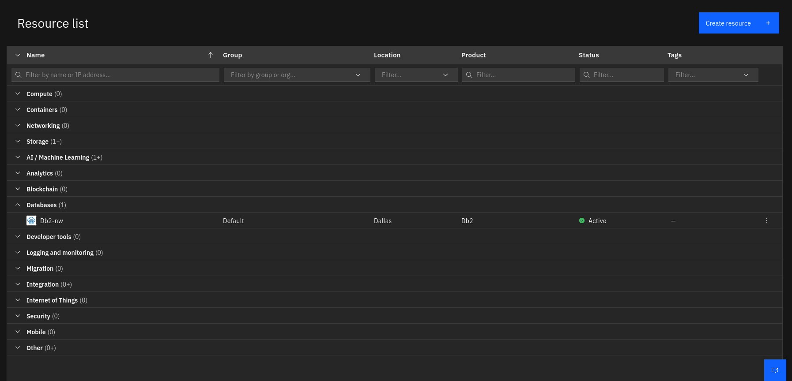**DATABASE CONNECTION:**

|  |
| --- |
| import ibm_db |
| conn = None |
|  |
| def get_db(): |
| global conn |
| print(conn) |
| if conn == None: |
| conn =  ibm_db.connect("DATABASE=bludb;HOSTNAME=9938aec0-8105-433e-8bf9-0fbb7e4 |
| 83086.c1ogj3sd0tgtu0lqde00.databases.appdomain.cloud;PORT=32459;SECURIT |
| Y=SSL;SSLServerCertificate=DigiCertGlobalRootCA.crt;UID=yvp21124;PWD=jN |
| DAkHSrZNopa2oe",'','') |
| return conn |

**CREATING INSTANCE IN IBM CLOUD:**

**CREATING TABLES IN DATABASE**

